Project Management

Assessment ONE

WEI-CHE HUNG_18249 in wells college

|  |  |  |  |
| --- | --- | --- | --- |
| Name of Student | WEI-CHE HUNG | ID | 18249 |

**Assessment 1 – Case Study**

Contents

Instruction: 2

Duration: 2

Case Study: 2

Going Green application, Green IT Project Management 2

Project profile 2

4

Business situation 4

Your tasks: 5

Task 1: Identify Business Strategy and Gap 5

Analyse Strategy 5

Task 2: Recommend a feasible solution 7

Task 3: Produce a Project Charter 8

8

Task 4: Project Document 9

Task 5: Project Closure 12

Helpful web links to complete the assessment: 15

Search Index 16

## Instruction:

This task is to be completed individually. You need to analyse a case scenario and complete all the tasks mentioned after the scenario.

You need to demonstrate your IT project management ability to identify business strategy and gaps. You will also need to suggest a feasible solution to overcome identified gaps and produce a project charter along with a WBS to implement the proposed solution.

### Duration:

Trainer will set the duration of the assessment.

All my working could be checked <https://18249wic.github.io/T42023/>

## Case Study:

### Going Green application, Green IT Project Management

# Project profile

Going “Green” is a mission of many companies around the globe not just for reasons of environmental responsibility, but also for cutting costs in these extremely tight economic times. Green IT efforts represent a specific focus area within enterprises that hold attention to this trend. Green IT leverages information technology to streamline operations, cut costly waste, and reduce the impact on the environment. IT typically consumes only about 10% of an organization’s energy costs, but the net effect of a Green IT project is to go beyond just energy saving. To tackle the other 90%, a Green IT project extends into a variety of other departments, and to execute such an endeavour requires an effective project management function in order to identify and prioritize goals. A Green IT transformation can be a complex process.

Vital Statistics:

* Number of project tasks - 12
* Project duration - 16 months
* Project budget - $1,200,000
* Number of users - 50

Because I could not get Ms-Project software. I use google Sheets to made Gantt chart template:

I also think using a simple case, which I knew well, could be better for my learning. Go to website:

Link URL:

<https://docs.google.com/spreadsheets/d/1X3VwzEoMS4FgDdaK2XjUI01WsrnVW0VclPlweBSYmpQ/edit?usp=sharing>

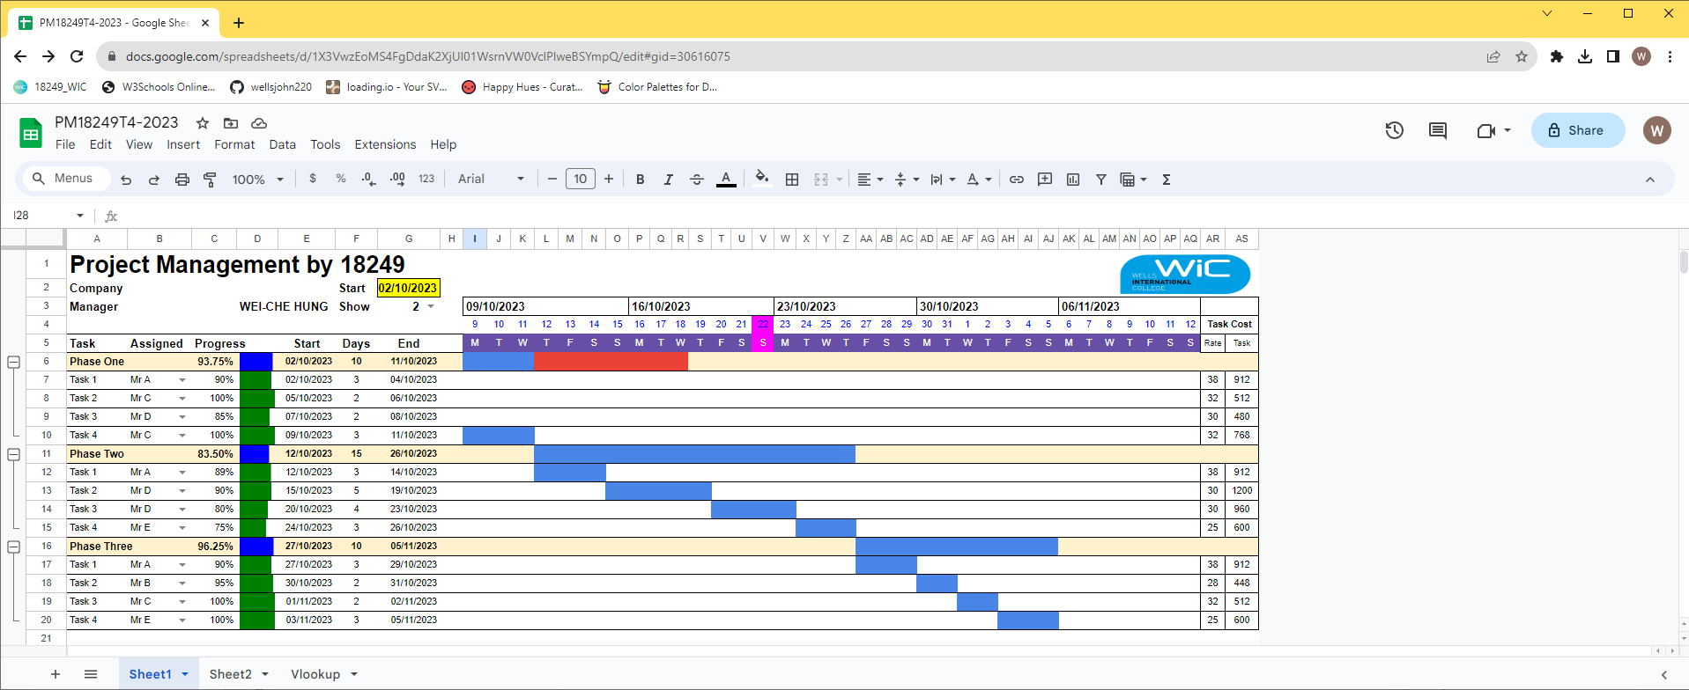

Tutor reference: <https://www.youtube.com/watch?v=8eKk0M2zGIk>

Or using GantProject (please note, if you do not use, just delete this section):

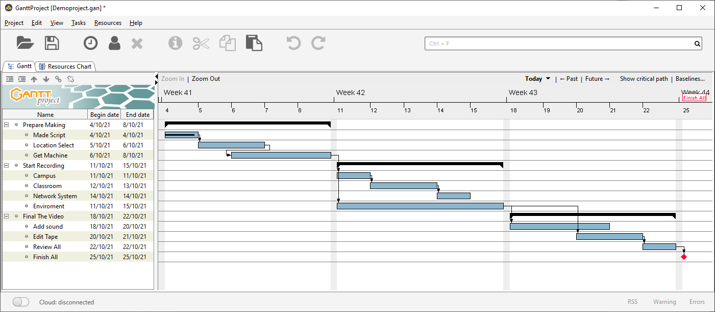

<https://wellsjohn220.github.io/projectwebsite/Demoproject-chart.html>

### 

### Business situation

Sample Summary Report:

In order help college promotion, the college need good video film. I set the project and start it now…

…

## Your tasks:

### Task 1: Identify Business Strategy and Gap

Document the business’s strategies of “Green IT” and also summarise the components required changes for the participating organisation to implement “Green IT Project”. (Min. 300 words)

Business strategy is a planning function of any organisation. Business strategy incorporates having a strategic plan.

### Analyse Strategy

The strategic plan of an organisation sets out the goals a business hopes to achieve within a specified period of time. It also helps the organisation understand the environment within which they operate and the market forces that affect them.

An analysis of the current strategic plan enables you to understand the goals of your organisation. However, in order to analyse the strategic plan, you first need to understand the structure and purpose of a strategic plan. This topic describes the elements that make up a strategic plan.

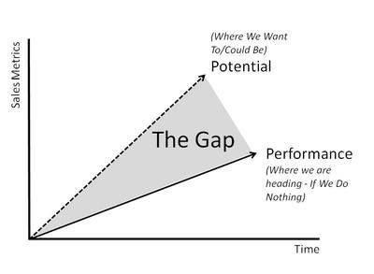The green project we need defined every requirement. The gap which is between your plan and reality always need your notice. So you need do your best to investigate your Green Project.

The "Green IT" strategy is a business approach that focuses on minimizing the environmental impact of an organization's Information Technology (IT) operations. It encompasses various practices and technologies designed to reduce energy consumption, minimize waste, and promote environmental sustainability within the IT sector. To successfully implement a "Green IT" project, an organization must address several key components:

1. **Energy Efficiency**: Implementing energy-efficient hardware and practices is a cornerstone of "Green IT." This involves optimizing data center operations, upgrading to energy-efficient servers, and adopting power management protocols to reduce energy consumption.
2. **Renewable Energy Sources**: Transitioning to renewable energy sources such as solar and wind power can significantly reduce an organization's carbon footprint. To achieve this, the organization should evaluate the feasibility of renewable energy installations or the purchase of green energy credits.
3. **E-Waste Management**: Responsible disposal of electronic waste is crucial for sustainability. The organization should establish e-waste recycling programs and ensure the proper disposal or refurbishment of outdated IT equipment.
4. **Sustainable Procurement**: Adopting sustainable procurement practices involves sourcing IT equipment and components that meet environmental standards. This includes looking for products with energy star ratings and considering the environmental impact of the supply chain.
5. **Telecommuting and Remote Work**: Encouraging remote work can reduce the organization's environmental impact by minimizing the need for physical office space and daily commuting. The organization should invest in secure remote work solutions and foster a flexible work culture.
6. **Paperless Operations**: Reducing paper usage through digital documentation, electronic signatures, and electronic workflows conserves resources and reduces waste. The organization should implement digital systems and provide employee training to promote paperless practices.
7. **Data Center Optimization**: Data centers are energy-intensive. To make them greener, the organization can implement data center consolidation, optimize cooling systems, and employ advanced monitoring and management tools to reduce energy consumption.
8. **Employee Training**: Educating employees about the environmental impact of their actions is essential. Training programs can promote green practices, from turning off computers when not in use to using energy-efficient settings.
9. **Monitoring and Reporting**: Continuous monitoring of energy consumption and environmental impact is critical. The organization should develop key performance indicators (KPIs) to track progress and provide regular reports to stakeholders.
10. **Compliance and Certifications**: Adhering to environmental regulations and obtaining certifications such as ISO 14001 demonstrates the organization's commitment to "Green IT" and its environmental responsibility.

Implementing a "Green IT" project requires a comprehensive and multifaceted approach that affects various aspects of IT operations and business practices. This strategy not only contributes to environmental sustainability but can also lead to cost savings, improved brand reputation, and increased competitiveness in a world where environmental concerns are increasingly important to customers and stakeholders.

### Task 2: Recommend a feasible solution

Assume “Wells International College” is thinking of going “Green” and asked for your assistance in this project. Research different project management applications on the Internet to compare with the Green IT project management application and recommend a feasible solution with proper reasons for Windsor. (Min. 300 words)

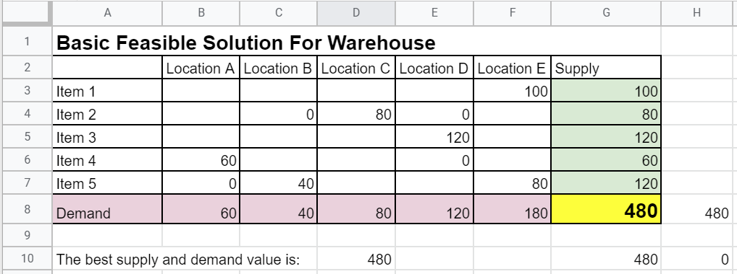

In any warehouse, it is crucial that the supply closely matches or equals the demand; this is the optimal business solution."

### Task 3: Produce a Project Charter

Please view my project charter (here only show part):

Develop a project charter for the Windsor project specifying project start date, finish date, approximate budget, project manager, project team with roles and responsibilities, project objective, project approach and stakeholders.

Name: ?

Description: Help business

Manager: John

Date Approved:

...

### 

### Task 4: Project Document

Please check my site: <https://18249wic.github.io/T42023/>

Please replace the images by yours below:

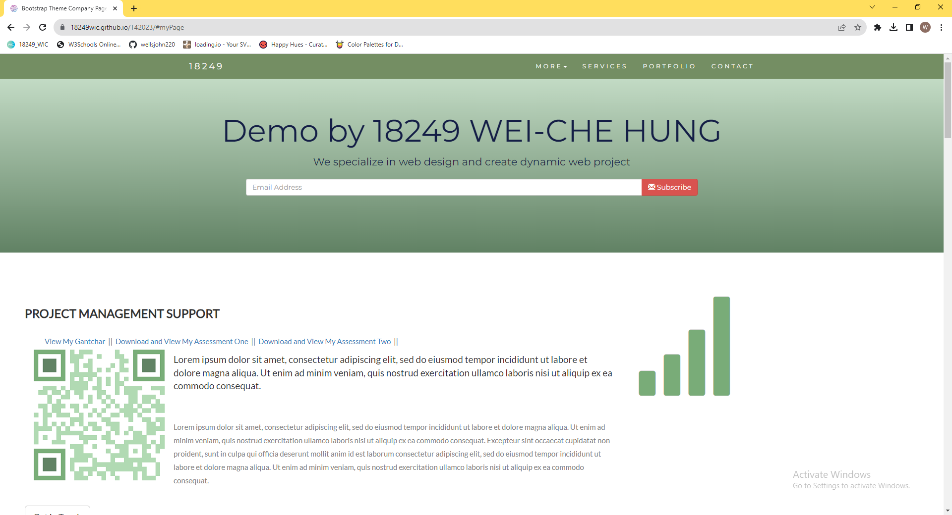

Please update below the contents about goal and cost

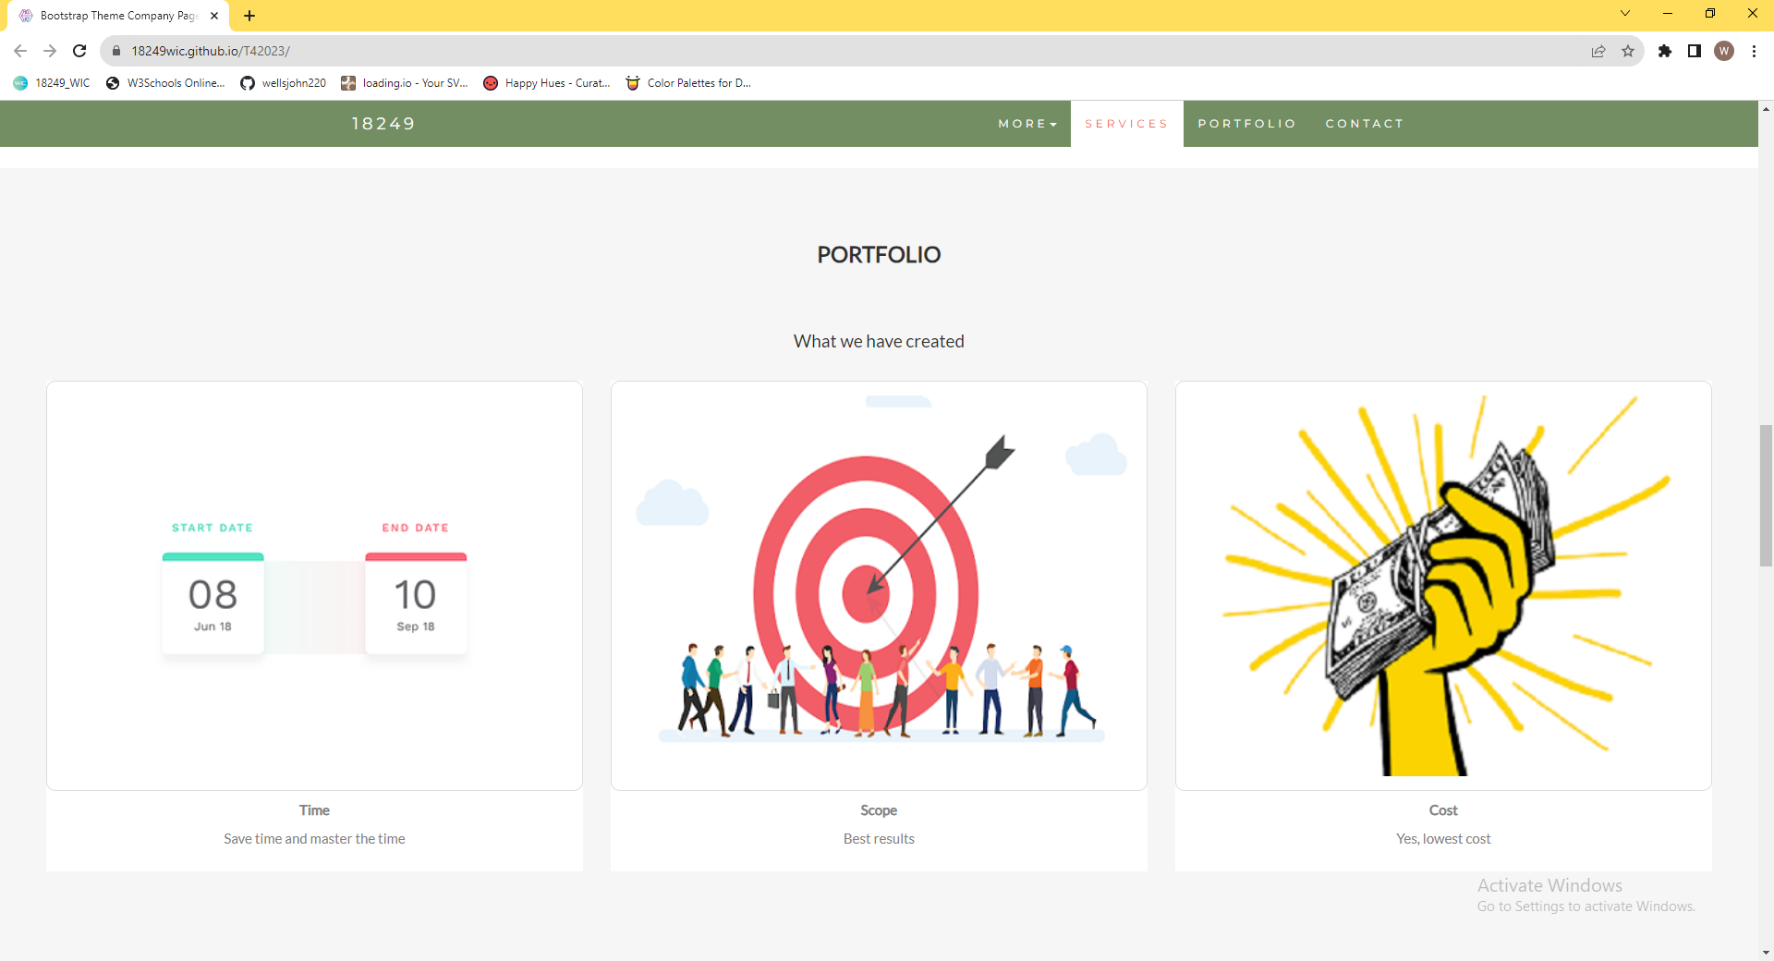

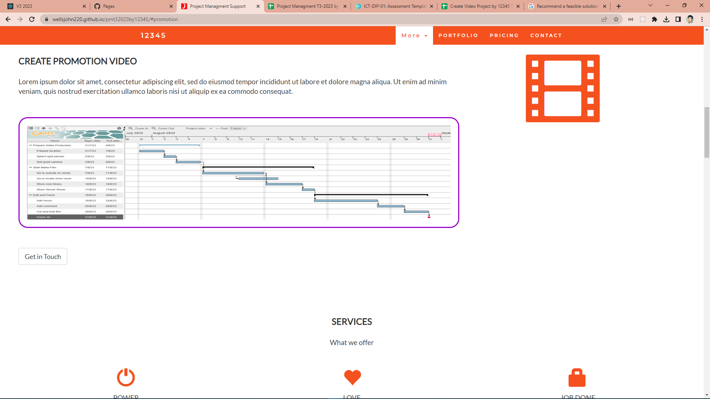

Refer to your current project, you have been asked to develop a project plan for WIC. Project plan outline as following:

In my Green project, I design following topics:

* Introduction (Select one recommendation from Task 2 for implement project plan)

(Please see above my project charter, it is clear indication)

* Project background

(Make promotion video for the college)

* Related factor to organization
* Scope and objective of the project
* Information gathering plan and approach
* Gathering method, can be one of the following
* Interview
* Questionnaire
* Observation
* Detail of information repositories
* Feasibility studies
* Technical (need higher tech made this software more stable and powerful)
* Operational
* Economical
* Social
* Project plan and schedule (Development and Maintenance)
* Work breakdown structure
* Gantt Chart
* Milestone

Above last black diamond is the milestone!

* Project Deliverable
* Communication plan

Communication plan should include communication and consultation with all the relevant stakeholders. (From college learn guide)

* Deployment Plan (If needs)
* Training Plan (If needs)
* Recourse and budget, (budget has been limited by WIC Capital Expenditure of current fiscal year for Hardware $80,000, Software $10,000, and Outsourcing man-hours $100,000)

Above image is showing my current green project displaying part of budget!

* Risk Management
* Risk identified
* Contingency plan
* Change management
* Change control
* Conflict management

### Task 5: Project Closure

Prepare project closure document template as following:

* Project Sign-off document

When project sign off, it means your project finished. So you need make one clear sheet to tell everyone about your project. It will include:

* project start date
* project manager
* project finish date
* if something is going wrong
* ...

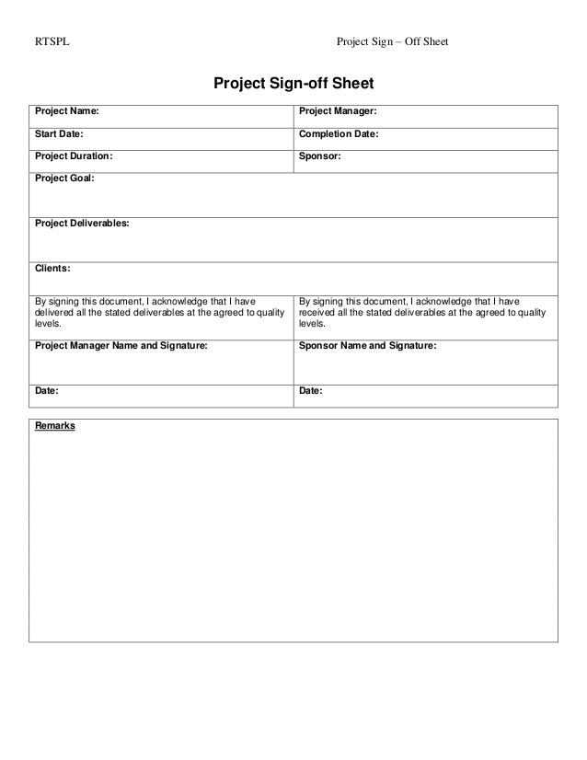

* Project evaluation document

You need show about your project, good or not enough. Summary all about your project

It may include:

* Budget evaluation
* Quality evaluation
* Benefit evaluation
* Etc...

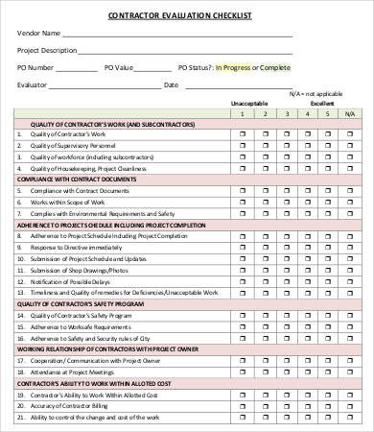

* Lesson learned template
* What we have learn through this project
* What we need to do if next project start
* What we learn some lesson. We could not make same mistake again.
* Etc.

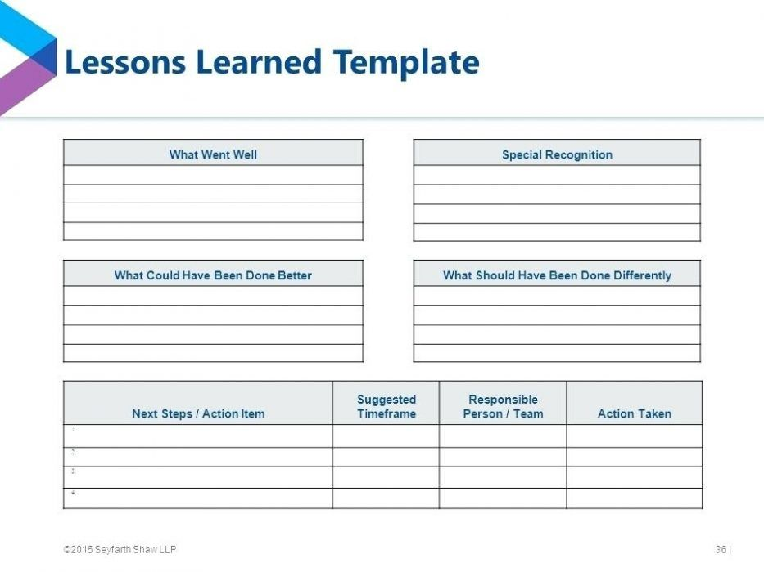

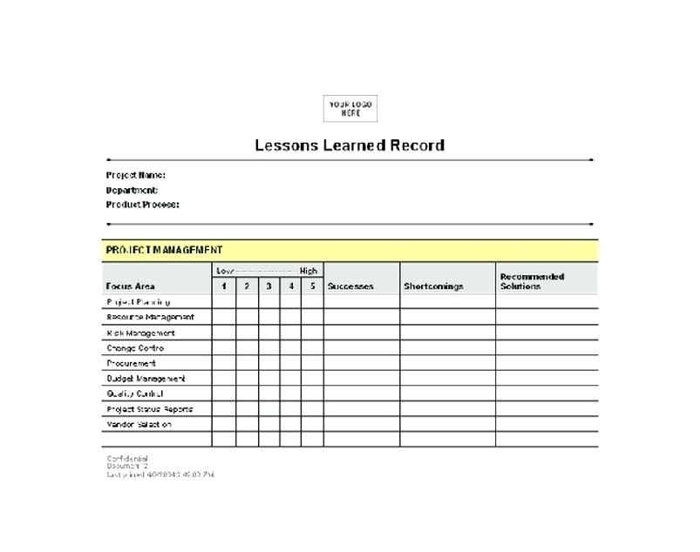

## Helpful web links to complete the assessment:

## Search Index

B

Benefit evaluation 10

Budget evaluation 10

F

feasible solution 1, 4

P

project sign off 9

Q

Quality evaluation 10

S

same mistake 10

scenario 1

specific focus 2